📄 Purchase Price Forecasting – Business Explanation Document
Purpose
The Purchase Price Forecaster is a data-driven tool designed to estimate the expected future price per unit of a specific part code.
It uses historical purchase data (10+ years) and official U.S. inflation data (CPI) to provide reliable forward-looking price estimates.
The goal is to support:
- Budget planning
- Purchase timing decisions
- Cost forecasting
- Supplier price validation
- Financial risk management

1️⃣ What Data Is Used
The model uses two main data sources:
A) Historical Purchase Orders (PO Data)
From our internal system, including:
- Part Code
- Order Date
- Price Per Unit
- Currency
This gives us at least 10 or more years of real purchase behavior for each part code.
B) U.S. Consumer Price Index (CPI)
Official inflation data published monthly.
Why CPI matters:
- Some price increases are due to general inflation.
- Some increases are supplier-specific.
- The model separates these two effects.

2️⃣ How the Forecast Works (Business View)
The system follows six logical steps:
Step 1 – Build Monthly Price History
We calculate the average monthly price per unit for each part code.
This smooths out one-time spikes and gives a stable trend.
Step 2 – Adjust for Inflation
We convert historical prices into “real dollars.”
This means:
We remove the effect of inflation to see the true supplier pricing behavior.
This answers:
Is the supplier increasing prices beyond normal inflation?
Step 3 – Detect Long-Term Patterns
The system uses a proven time-series method (SSA – Singular Spectrum Analysis) to detect:
- Trends
- Seasonality
- Cycles
- Long-term movement
It does not guess.
It learns patterns from historical data.
Step 4 – Forecast Real Price
The model predicts how the supplier’s underlying price behavior is likely to continue.

Step 5 – Forecast Inflation
The model separately forecasts CPI (inflation) using historical CPI data.
Step 6 – Reconstruct Future Purchase Price
Finally, it combines:
- Predicted real supplier behavior
- Predicted inflation
To produce the expected future nominal purchase price.
This is the actual dollar amount we expect to pay.

3️⃣ Why This Forecast Is Reliable
✔ Based on at least 10 or more Years of Real Purchase Data
The model uses actual historical transactions from our company.
This is not generic industry data — it is our real supplier history.
✔ Uses Monthly Aggregation
Monthly averages reduce noise and one-off anomalies.
✔ Separates Inflation from Supplier Pricing
This is critical.
Instead of blindly projecting past prices, the model:
- Removes inflation
- Forecasts true supplier behavior
- Adds projected inflation back in
This improves realism and prevents double-counting inflation effects.

✔ Uses Proven Statistical Method (SSA)
Singular Spectrum Analysis:
- Is widely used in finance and economics
- Detects seasonal and cyclical behavior
- Handles long historical series well
- Is stable for medium-term forecasting
✔ Uses Log Transformation for Stability
The model uses a logarithmic transformation to:
- Prevent negative forecasts
- Improve accuracy
- Stabilize variance
- Handle multiplicative growth correctly
This increases reliability of long-term predictions.

4️⃣ What the Output Means
Example:
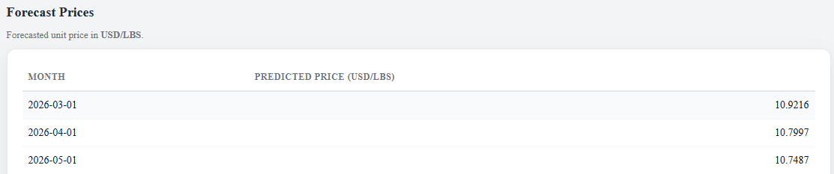
This means:
If we were to purchase this part code in March 2026, the expected price per unit is approximately $10.92.
Now if we were to purchase in May 2026, the expected price per unit is approximately $10.75.

This gives planning a new perspective based on the forecast assessment that reflects:
- Supplier pricing behavior
- Inflation expectations
- Long-term trend patterns

5️⃣ Why Purchasing Should Use This Tool
🎯 1. Budget Planning
Provides forward-looking pricing instead of relying only on last purchase price.
🎯 2. Early Warning System
If forecast shows upward trend:
- Consider early purchase
- Negotiate contracts sooner
- Lock pricing
🎯 3. Supplier Negotiation Support
If a supplier proposes a large increase:
- Compare proposal to forecasted expected price
- Identify abnormal increases
- Strengthening negotiation position
🎯 4. Risk Reduction
Forecast includes statistical confidence ranges (in detailed mode).
Helps understand:
- Best-case scenario
- Likely scenario
- Conservative scenario

6️⃣ When Accuracy Is Highest
The forecast is most accurate when:
- There are many years of historical data
- Purchase activity is consistent
- No major supplier disruption occurred
- Forecast horizon is short to medium term (3–12 months)

7️⃣ When Caution Is Needed
Accuracy may decrease when:
- A part has not been purchased recently
- A supplier has changed pricing strategy
- Market conditions changed drastically
- Forecasting multiple years beyond last purchase
The system will still provide estimates, but they should be interpreted carefully.

8️⃣ What This Tool Is NOT
It is not:
- A market speculation tool
- A guarantee of future price
- A replacement for supplier negotiation
It is:
A statistical planning tool based on historical behavior and inflation dynamics.

9️⃣ Summary for Purchasing Team
This forecasting tool:
- Uses our real purchase history
- Separates inflation from supplier behavior
- Applies proven statistical modeling
- Produces realistic forward price estimates
- Helps reduce budgeting uncertainty
- Improves purchasing strategy decisions
It should be used as a planning aid before making future purchase commitments.

